Kyle Rayner

ksrayner@deakin.edu.au

Abstract

This report outlines the core functionalities of the Cycling Against Friends/Ghosts feature as a ‘Must Have’ and ‘Would Like’ list. The report proceeds to showcase a roadmap for development for this feature to get it to a working prototype.

Roadmap for cycling against friends/GHosts feature

SIT378 – Team Project (B) – Execution and Delivery

Contents

Introduction 2

Features 2

Must Have Features: 2

Would Like Feature: 2

Roadmap 2

Conclusion 4

References 4

Appendix 4

Appendix A. 4

Appendix B. 5

# Introduction

This report will outline the ‘must have’ & ‘would like’ features and also a four week/cycle development roadmap for the Cycling Against Friends/Ghosts feature. The intention is to get a working prototype done by the end of the fourth development cycle with the ‘must have’ features completed. If time permits, some ‘would like’ features may be implemented as well.

# Features

As mentioned above, the ‘must have’ & ‘would like’ features will be provided below:

## Must Have Features:

* The player must be able to compete against another person
* The player must be able to compete against their own personal best time (Ghost)
* The player must have at least one track/course/circuit/distance/other to compete on
* The player must be able to see statistics on both their own performance, the performance of their competition (speed, distance completed, etc) and clearly indicate who is winning
* For the mobile version, in accordance with the Figma designs, the player must have access to the first two interfaces as shown in Appendix A.

## Would Like Feature:

* For the mobile version, in accordance with the Figma designs, the player has access to the final interface as shown in Appendix A.
* For the mobile version, the player will be able to select coordinates from a map and use that as the course/track when competing against a friend or ghost
* The player can choose from more than one track/course/circuit/distance to compete on
* The player can compete against other people’s ghosts (e.g., friend’s ghost or a preloaded ghost from another person’s performance)

# Roadmap

|  |  |
| --- | --- |
| **Development Cycle 1:** | * The player must be able to compete against their own personal best time (Ghost) * Focusing on the core aspect of the feature by adding the ability to compete against your ghost in its most basic form. * The player must have at least one track/course/circuit/ distance/other to compete on * For the mobile version, a distance such as 10km or 20km would suffice. A countdown timer like what is shown in Appendix A. would also be a viable option. * For the video game version, a track, circuit or course would be more appropriate to add to the immersive experience. |
| **Development Cycle 2:** | * The player must be able to compete against another person * This adds to the work done in Development Cycle 1. * Mostly involves setting up another bike and being able to compete against the person on it. * Finishing Figma designs for both starting a workout and ending a workout for this feature * Most of the design work is done. However, to prepare for the next development cycle, all the Figma designs should be complete. |
| **Development Cycle 3:** | * The player must be able to see statistics on both their own performance, the performance of their competition (speed, distance completed, etc) and clearly indicate who is winning * For the video game version, most of this information will be located in one of the corners via a heads-up display (HUD). To indicate who is winning, text in the top-middle of the screen will appear periodically as shown in Appendix B. * For the mobile version, in accordance with the Figma designs, the player must have access to the first two interfaces as shown in Appendix A. * These two interfaces provide vital information regarding their own performance and the performance of their competition |
| **Development Cycle 4:** | * Finishing off any work from previous development cycles * Chance to catch up on any work from previous weeks * Quality assurance and testing * Wrap up any development and ensure the feature is in a working state * Work on ‘Would Like’ features if time permits * Some of the ‘Would Like’ features from the list above may be implemented at this point. |

# Conclusion

This report has presented the most fundamental aspects of the Cycling Against Friends/Ghosts feature and includes a 4-week development roadmap to end with a working prototype.

# References

Bains C (2022) You can now pedal around GTA 5 using real-life smart bike, TechRadar, accessed 9 November 2022. <https://www.techradar.com/news/you-can-now-pedal-around-gta-5-using-a-real-life-smart-bike>

Rockstar North (2013) Grand Theft Auto V, Computer Program, Edinburgh, Scotland

# Appendix

## Appendix A.

For a more comprehensive view of all the Figma Designs: <https://www.figma.com/file/tvpePId4wuKneyD9faU1yw/Mobile-App-Flow?node-id=0%3A1>

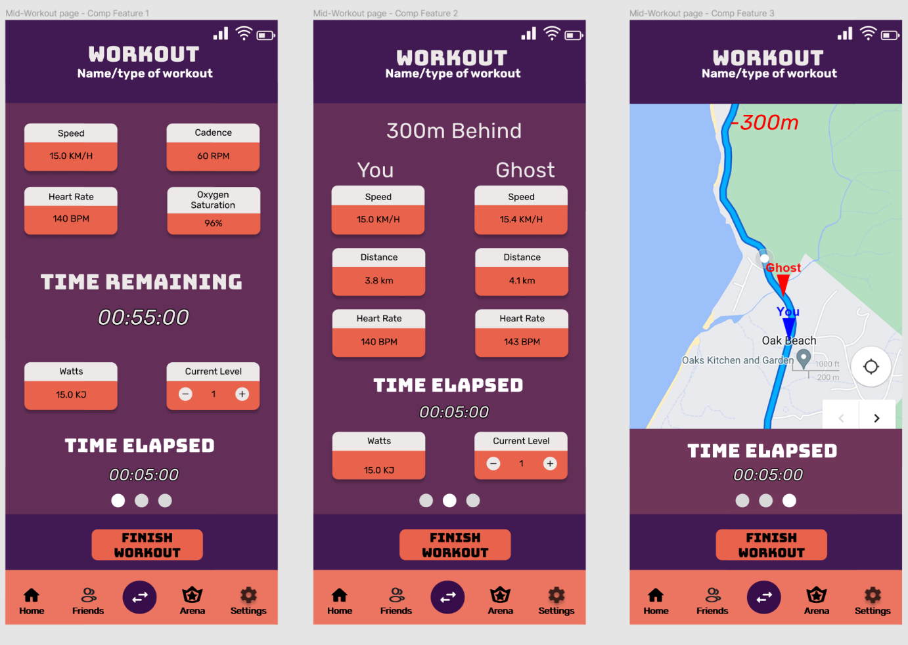

Figure – The three interfaces that are shown mid-workout for the Cycling Against Friends Feature

## Appendix B.

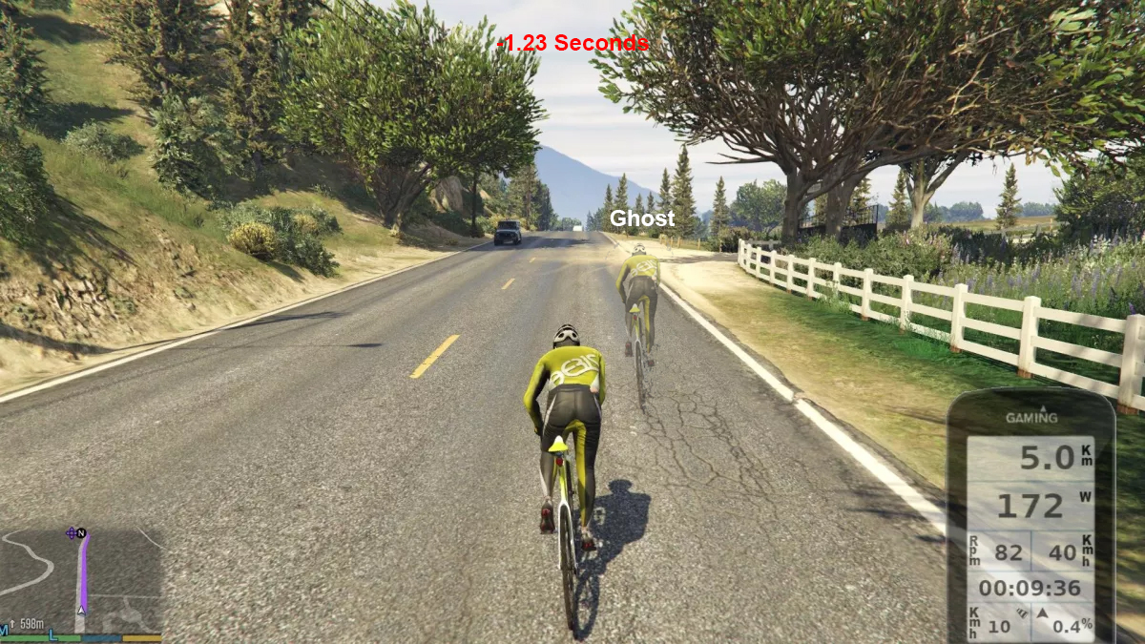

Figure – Initial design of the Cycling Against Friends/Ghosts Feature in a video game solution